Go to HANA Modeler. Select your package. Create a decision table. Add Z104329EMP to the data foundation node. Select Empno, Ename, Sal and Deptno as Output.

Create parameter as BONUS_PERC.

Right Click on Sal . Add as condition.

Add Bonus_Perc as action.

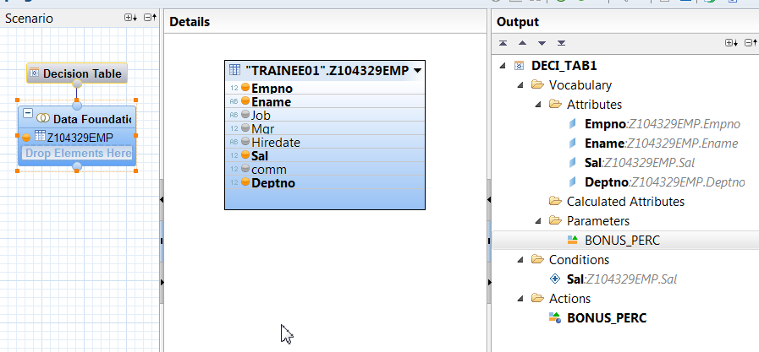

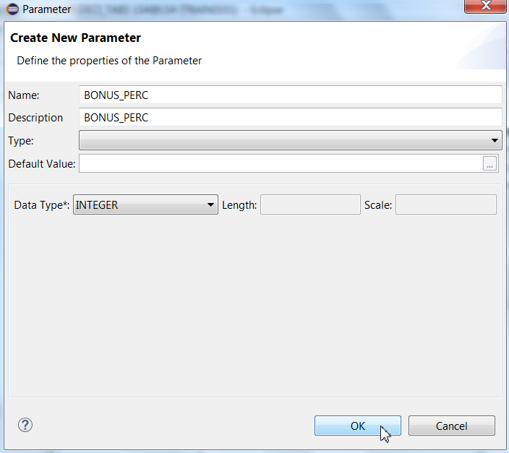

Create decision table as shown below.

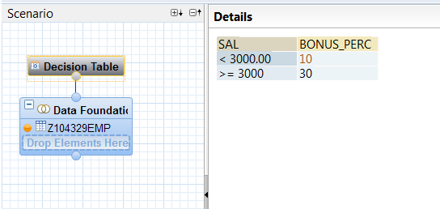

Create calculation View for decision table.

Add the emp table, in the first projection.

Add the Decision table in the second projection.

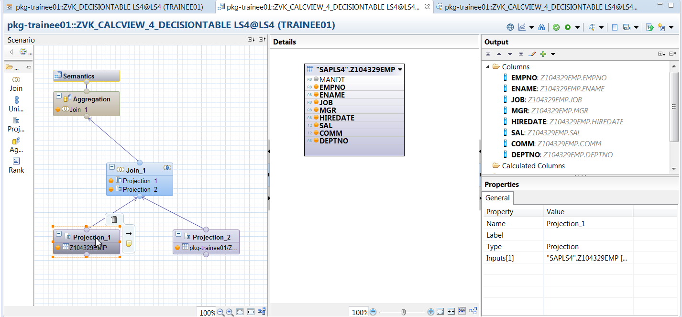

Select the following fields as Output from the EMP table.

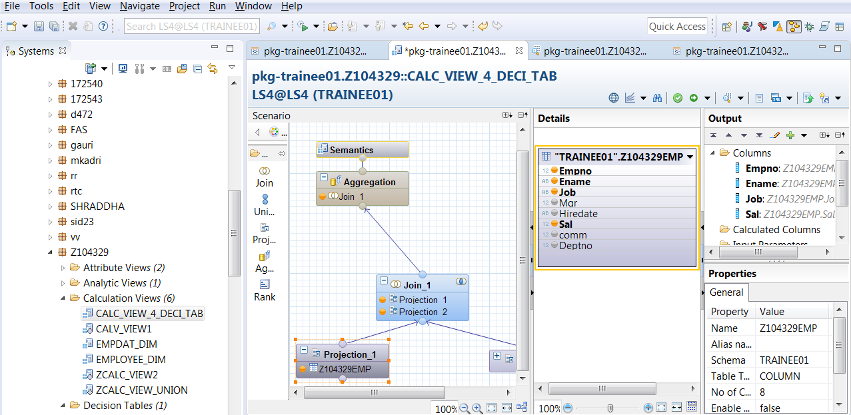

Select the following fields as Output from the Decision table.

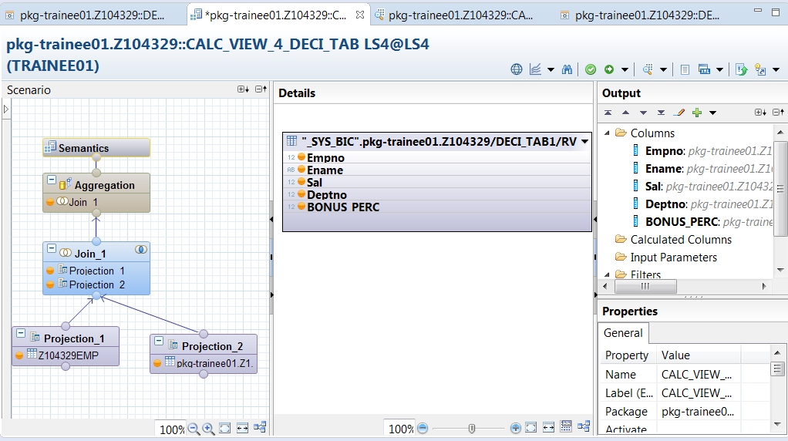

Drag Projection1 and Projection 2 on the Join. Join on Empno.

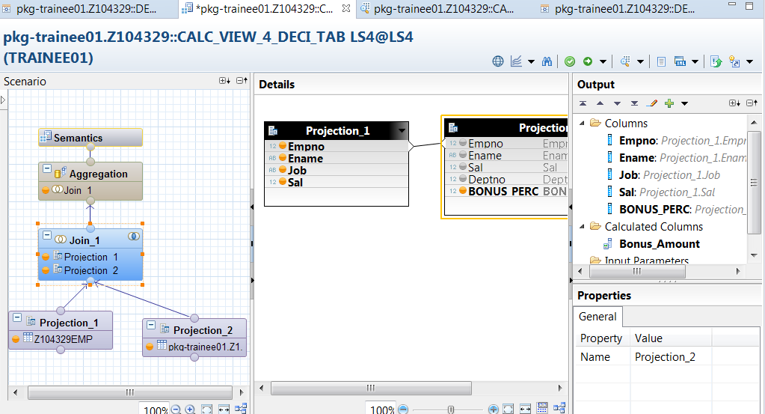

Create a calculated column as below.

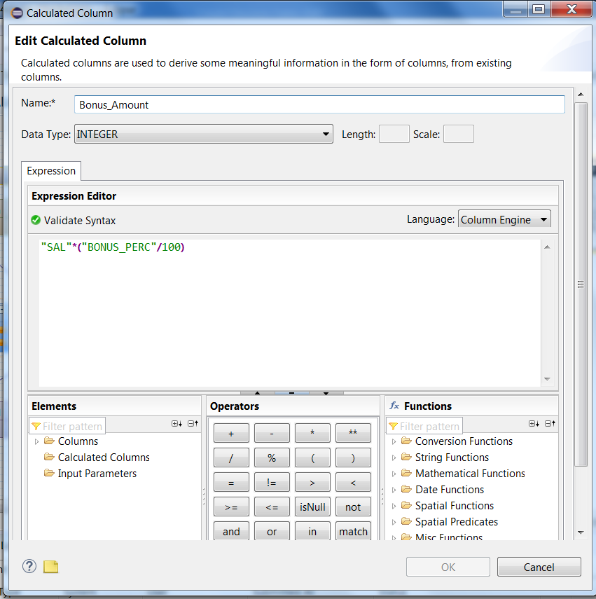

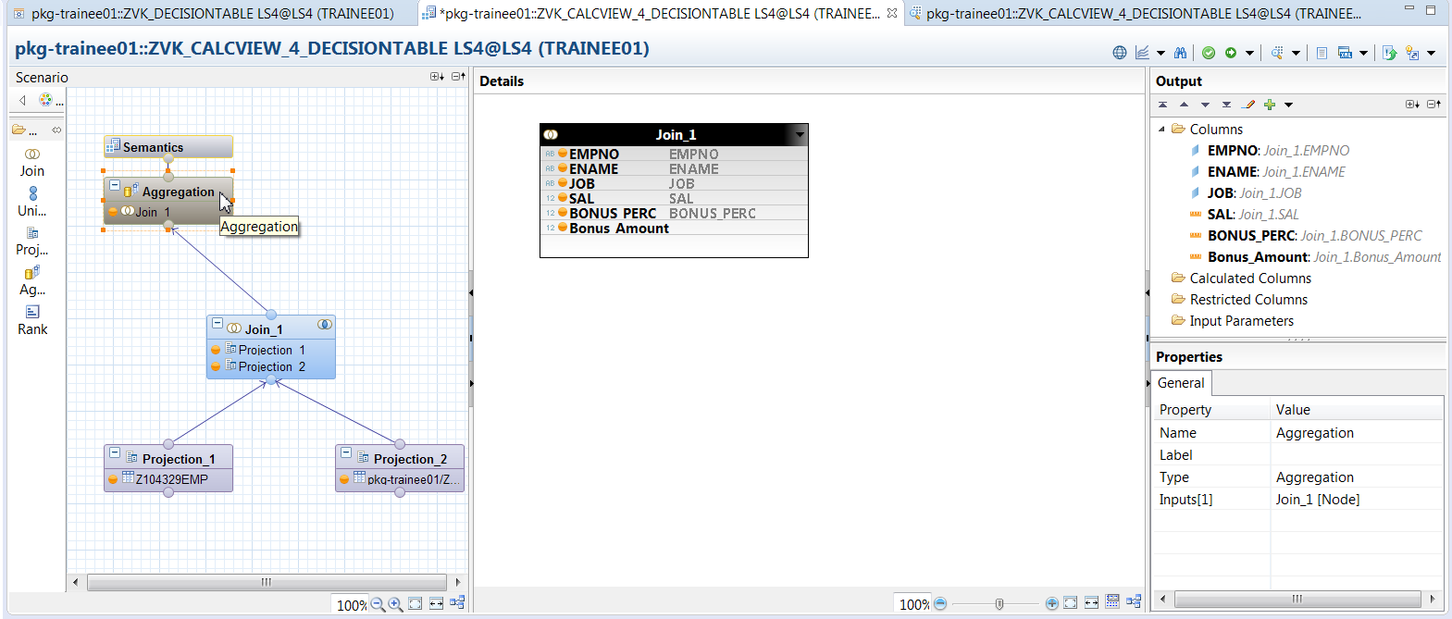

Drag join to the aggregation node. Select the fields as OP.

